**Creating Microservices for account and loan**

**AccountController.java**

package com.cognizant.account.controller;  
  
import org.springframework.web.bind.annotation.*;  
import java.util.*;  
  
@RestController  
@RequestMapping("/accounts")  
public class AccountController {  
  
 @GetMapping("/{number}")  
 public Map<String, Object> getAccountDetails(@PathVariable String number) {  
 Map<String, Object> account = new HashMap<>();  
 account.put("number", number);  
 account.put("type", "savings");  
 account.put("balance", 234343);  
 return account;  
 }  
}

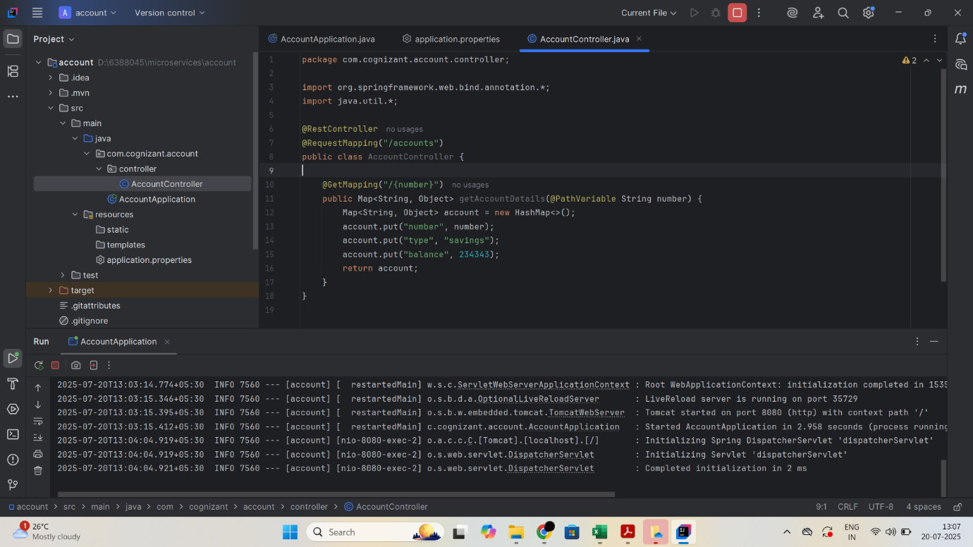

**OUTPUT:**

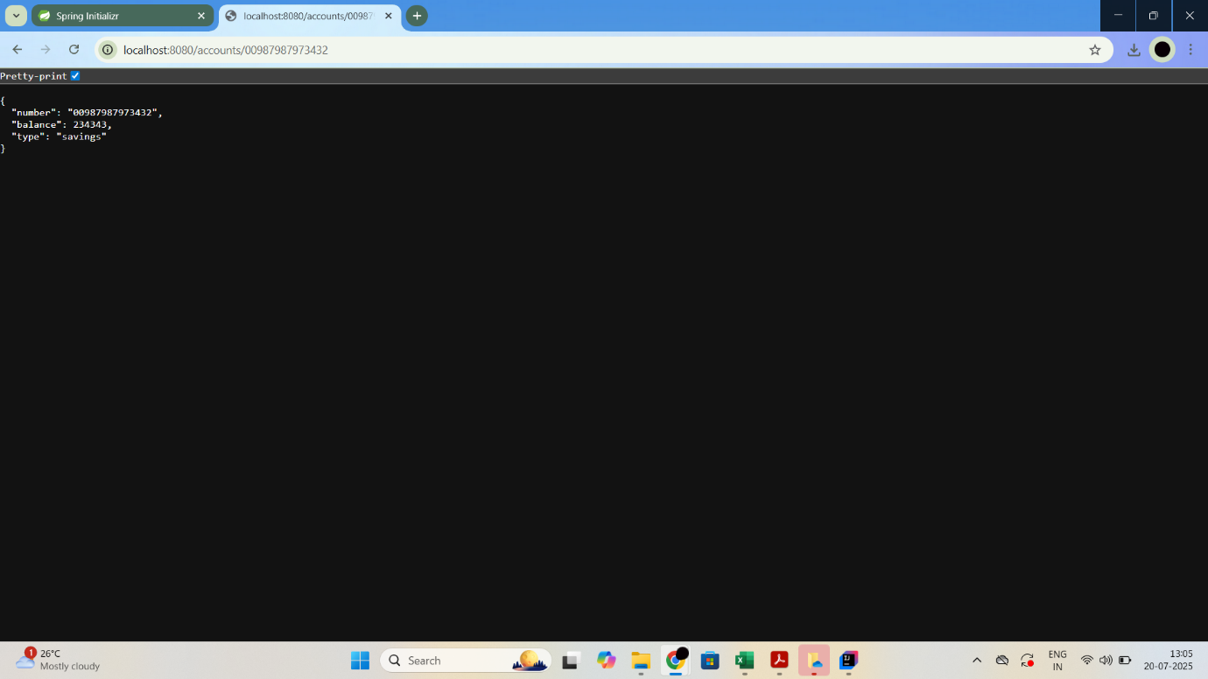

**LoanController.java**

package com.cognizant.loan.controller;  
  
import org.springframework.web.bind.annotation.GetMapping;  
import org.springframework.web.bind.annotation.PathVariable;  
import org.springframework.web.bind.annotation.RestController;  
import java.util.HashMap;  
import java.util.Map;  
  
@RestController  
public class LoanController {  
  
 @GetMapping("/loans/{number}")  
 public Map<String, Object> getLoanDetails(@PathVariable String number) {  
 Map<String, Object> loanDetails = new HashMap<>();  
 loanDetails.put("number", number);  
 loanDetails.put("type", "car");  
 loanDetails.put("loan", 400000);  
 loanDetails.put("emi", 3258);  
 loanDetails.put("tenure", 18);  
 return loanDetails;  
 }  
}

**application.properties**

spring.application.name=loan  
server.port=8081

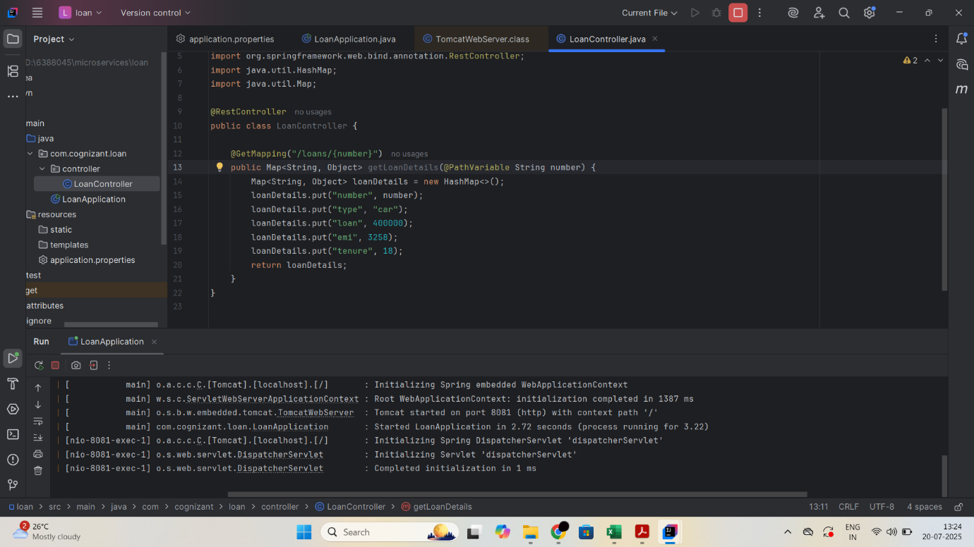

**OUTPUT:**

